CHAPTER FOUR
DATA PRESENTATION AND ANALYSIS
  - Preamble
In this chapter, we delve into the heart of the research by carefully analyzing the collected data and presenting the findings in a clear and coherent manner. The goal of this chapter is to transform raw data into meaningful insights that address the research questions and objectives outlined earlier in the study. The presentation of results was derived from responses received from the respondents. Descriptive statistics such as percentages, frequencies, mean and standard deviation were used to summarize the demographic data and responses of the questionnaire. Regression analysis was employed to test the hypotheses while putting the null hypotheses to test.

  - Descriptive analysis of the socio-demographic data of the respondents
The socio-demographic characteristics of respondents are crucial for understanding the content of the research and to also provide insights into the diversity and representativeness of the sample.
S/N | Variables |  | (N) | (%)
 | Age | 20–29 | 155 | 77.5%
 | Age | 30–39 | 25 | 12.5%
 | Age | 40–49 | 15 | 7.5%
 | Age | 50 and above | 5 | 2.5%
 | Age | Total | 200 | 100%
 | Gender | Male | 92 | 46
 | Gender | Female | 108 | 54
 | Gender | Total | 200 | 100%
 | Years of experience | Less than 5 years | 148 | 74%
 | Years of experience | 6–10 years | 37 | 18.5%
 | Years of experience | 11–15 years | 11 | 5.5%
 | Years of experience | Above 15 years | 4 | 2%
 | Years of experience | Total | 200 | 100%
 | Current role in the organization | Underwriter | 47 | 23.5%
 | Current role in the organization | Claims Officer | 29 | 14.5%
 | Current role in the organization | Actuary | 23 | 11.5%
 | Current role in the organization | Customer Service Rep | 12 | 6%
 | Current role in the organization | IT/InsurTech Professional | 14 | 7%
 | Current role in the organization | Others | 75 | 37.5%
 | Current role in the organization | Total | 200 | 100%
 | Type of organization | Life Insurance | 52 | 26%
 | Type of organization | General Insurance | 59 | 29.5%
 | Type of organization | Reinsurance | 16 | 8%
 | Type of organization | InsurTech Firm | 18 | 9%
 | Type of organization | Others | 55 | 27.5
 | Type of organization | Total | 200 | 100%

INTERPRETATION
The socio demographic details of the respondents displayed above shows the percentages and frequencies of various categories associated with the respondents. Regarding the age, the highest group of respondents falls within the 20 – 29 years age range, comprising 155 participants which accounts for 77.5% of the total. The next significant group is 30 - 39, with 25 respondents accounting for 12.5% of the total, followed by age group 40 - 49 with 43 respondents (15.9%), and finally 50 and above with 5 respondents (2.5%) as depicted above.

The gender distribution shows a significant advantage towards the female gender with 108 respondents as it accounts for 54% of the population compared to 92 males which represents 46% of the population.’

In terms of years of experience, the majority of respondents fall within the category of “less than 5 years” with 148 respondents accounting for 74% of the total. The next is 6 – 10 years with 37 respondents which accounts for 18.5% of the population, followed by 11 – 15 years which accounts for 5.5% of the total and finally above 15 years with 4 respondents which is 2% of the total.

Also, the role with the highest number of respondents is underwriter with 47 respondents (23.5%), followed by claims officer with 29 respondents (14.5%), actuary comes next with 23 respondents (11.5%), followed by IT/InsurTech Professional with 14 respondents (8.1%,) and finally Customer Service Rep with 12 respondents (6%) while those that chose not to state their roles accounts for 37.5% of the total with 75 respondents.

The type of organization with the highest respondents is general insurance with 59 respondents (29.5%), followed by life insurance with 52 respondents (26%), InsurTech Firm with 18 respondents (9%), Reinsurance with 16 respondents (8%), while 55 respondents chose not to state their organization type accounting for 27.5% of the total.

The detailed breakdown of the respondents’ demographic characteristics provides a comprehensive understanding of the diversity within the sample population and also ensures that the findings reflect a broad spectrum of perspectives.

  - Descriptive Analysis of Respondents to Research Instrument
Research Question 1: AI Benefits in Insurance Operations
S/N | ITEMS | SA | A | N | D | SD | Mean | S. D
1 | AI improves the speed and accuracy of underwriting. | 39  (19.5) | 93  (46.5) | 36  (18) | 16  (8.0) | 16  (8.0) | 3.65 | 1.13
2 | AI enhances fraud detection and reduces fraudulent claims. | 34  (17) | 86  (43) | 37  (18.5) | 37  (18.5) | 6  (3) | 3.52 | 1.07
3 | AI streamlines claims processing and settlement time. | 41  (20.5) | 86  (43) | 47  (23.5) | 18  (9.0) | 8  (4.0) | 3.67 | 1.03
4 | AI enhances customer service through chatbots and virtual assistants. | 42  (21) | 98  (49) | 33  (16.5) | 17  (8.5) | 10  (5.0) | 3.73 | 1.05
5 | AI improves data-driven decision-making in insurance operations. | 59  (29.5) | 86  (43) | 32  (16) | 16  (8) | 7  (3.5) | 3.87 | 1.04

Interpretation of table data:
For question 1: “AI improves the speed and accuracy of underwriting.”. 26.2% of the respondents strongly agree, 43.2% agree, 13.7% are neutral, 8.9% disagree while 8.1% strongly disagreed. For research question 2, “AI enhances fraud detection and reduces fraudulent claims.”. 18.5% of the respondents strongly agreed, 38.4% agree, 29.2% are neutral 10% disagree while 4.1% strongly disagreed. For research question 3: “AI streamlines claims processing and settlement time.”. 13.7% strongly agree, 44.6% agreed, 26.2% are neutral 9.2% disagreed while 6.3% strongly disagreed. For research question 4, “AI enhances customer service through chatbots and virtual assistants”, 19.6% of the respondents strongly agree, 43.9% agree, 21.4% are neutral 10% disagree while 5.2% strongly disagreed. For research question 5, “AI improves data-driven decision-making in insurance operations.”, 19.6% of the respondents strongly agree, 43.9% agree, 21.4% are neutral 10% disagree while 5.2% strongly disagreed.

Research Question 2: Socio-Economic Impact of AI on Employment
S/N | ITEMS | SA | A | N | D | SD | Mean | S. D
1 | AI adoption in insurance is creating new job opportunities. | 26  (13) | 83  (41.5) | 37  (18.5) | 35  (17.5) | 19  (9.5) | 3.31 | 1.18
2 | AI reduces the relevance of some traditional roles in the insurance sector. | 36  (18) | 97  (48.5) | 35  (17.5) | 17  (8.5) | 15  (7.5) | 3.61 | 1.11
3 | AI requires insurance professionals to acquire new digital and analytical skills. | 60  (30) | 78  (39) | 30  (15) | 17  (8.5) | 15  (7.5) | 3.75 | 1.19
4 | AI adoption may lead to workforce downsizing in insurance firms. | 29  (14.5) | 96  (48) | 40  (20) | 29  (14.5) | 6  (3.0) | 3.56 | 1.01
5 | The integration of AI has more positive than negative socio-economic impacts. | 45  (22.5) | 79  (39.5) | 41  (20.5) | 24  (12) | 11  (5.5) | 3.62 | 1.12

Interpretation of table data:
For question 1: “AI adoption in insurance is creating new job opportunities.”. 19.5% of the respondents strongly agree, 46.5% agree, 18% are neutral, 8% disagree while 8% strongly disagreed. For research question 2, “AI reduces the relevance of some traditional roles in the insurance sector.”. 17% of the respondents strongly agreed, 43% agree, 18.5% are neutral 18.5% disagree while 3% strongly disagreed. For research question 3: “AI requires insurance professionals to acquire new digital and analytical skills.”. 20.5% strongly agree, 43% agreed, 23.5% are neutral 9.0% disagreed while 4% strongly disagreed. For research question 4, “AI adoption may lead to workforce downsizing in insurance firms.”, 21% of the respondents strongly agree, 49% agree, 16.5% are neutral 8.5% disagree while 5.0% strongly disagreed. For research question 5, “The integration of AI has more positive than negative socio-economic impacts.”, 29.5% of the respondents strongly agree, 43% agree, 16% are neutral 8% disagree while 3.5% strongly disagreed.

Research Question 3: AI in Decision-Making and Risk Management
S/N | ITEMS | SA | A | N | D | SD | Mean | S. D
1 | AI helps insurers make better predictions of customer behavior and risk. | 44  (22) | 96  (48) | 35  (17.5) | 12  (6.0) | 13  (6.5) | 3.73 | 1.07
2 | AI enhances risk management through predictive analytics. | 48  (14) | 90  (45) | 31  (15.5) | 13  (6.5) | 3  (1.5) | 3.73 | 1.08
3 | AI supports more accurate pricing and policy design. | 43  (21.5) | 104  (52) | 37  (18.5) | 13  (6.5) | 3  (1.5) | 3.86 | 0.88
4 | AI increases transparency and fairness in decision-making. | 52  (26) | 95  (47.5) | 29  (14.5) | 18  (9) | 6  (3.0) | 3.85 | 1.01
5 | AI has improved my organization’s overall efficiency in risk assessment. | 59  (29.5) | 87  (43.5) | 31  (15.5) | 13  (6.5) | 10  (5.0) | 3.86 | 1.07

Interpretation of table data:
For question 1: “AI helps insurers make better predictions of customer behavior and risk.”. 22% of the respondents strongly agree, 48% agree, 17.5% are neutral, 6% disagree while 6.5% strongly disagreed. For research question 2, “AI enhances risk management through predictive analytics.”. 14% of the respondents strongly agreed, 45% agree, 15.5% are neutral 6.5% disagree while 1.5% strongly disagreed. For research question 3: “AI supports more accurate pricing and policy design.”. 21.5% strongly agree, 52% agreed, 18.5% are neutral 6.5% disagreed while 1.5% strongly disagreed. For research question 4, “AI increases transparency and fairness in decision-making.”, 26% of the respondents strongly agree, 47.5% agree, 14.5% are neutral 9% disagree while 3% strongly disagreed. For research question 5, “AI has improved my organization’s overall efficiency in risk assessment.”, 29.5% of the respondents strongly agree, 43.5% agree, 15.5% are neutral 6.5% disagree while 5.0% strongly disagreed.

  - Test of Hypotheses (Inferential Statistics)
    - Hypothesis One
H_{o}: The integration of artificial intelligence does not significantly affect employment levels or job roles within the insurance industry.
H_{i}: The integration of artificial intelligence significantly affects employment levels or job roles within the insurance industry.

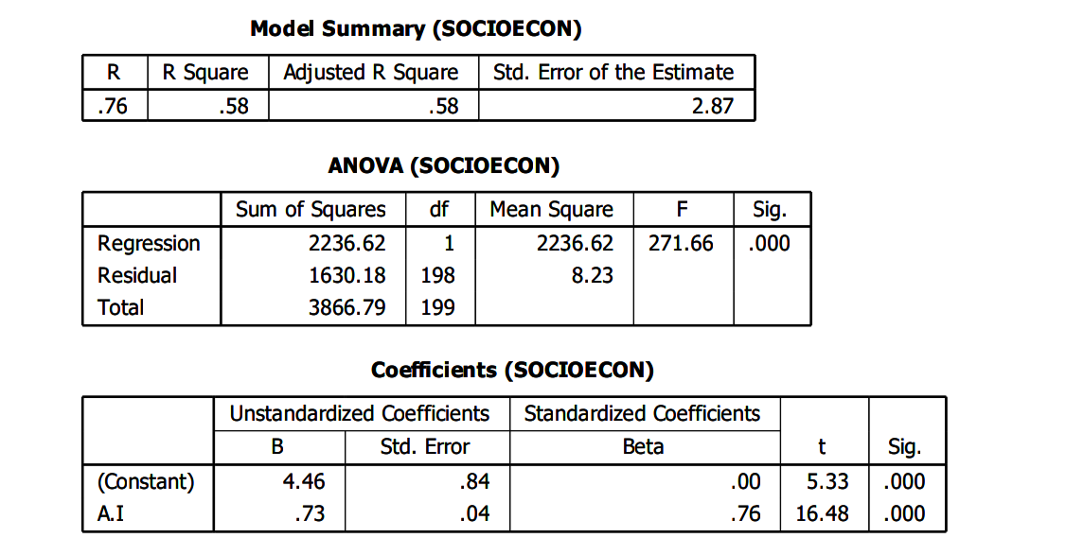
This shows the correlation coefficient between the predictor (A.I) and the dependent variable. A value of 0.76 indicates a strong positive relationship. R Square is .58 This means that 58% of the variance in socioeconomic outcome is explained by the independent variable (A.I). This is a fairly high explanatory power in social science research, where R² values above 0.50 are often considered substantial. Adjusted R Square is .58 Since there is only one predictor, the adjusted R² is the same. It shows that the model has not been inflated by the number of predictors. Std. Error of the Estimate is 2.87 This tells us about the average distance of the observed values from the regression line. Smaller values indicate a better model fit; here, the error margin is reasonable. Regression Sum of Squares = 2236.62, df = 1 This reflects the variation in “employment” explained by A.I. Residual Sum of Squares = 1630.18, df = 198 This reflects the unexplained variation (errors). Total Sum of Squares = 3866.79, df = 199 This is the total variability in “employment”. F = 271.66, Sig. = .000 The F-statistic is very large (271.66) and highly significant (p < 0.001). This indicates that the model overall is a good fit and that A.I significantly impacts employment. Since p < 0.05, we reject the null hypothesis that “A.I has no effect on employment”. Both the ANOVA (F-test) and the coefficient (t-test) confirm that A.I has a significant positive influence on SOCIOECON at the 1% level (p < 0.001). Thus, the relationship is not due to chance. The positive B coefficient (0.73) indicates that improvements in A.I (which might stand for "Access to Information," "Artificial Intelligence," or "Academic Initiative" depending on study context) are associated with improvements in socioeconomic outcomes. The regression results strongly justify the conclusion that A.I is a significant predictor of employment. The model is robust, statistically significant, and explains a substantial portion of the variation in the dependent variable.

    - Hypothesis Two
H_{o}: Artificial intelligence has no significant effect on underwriting accuracy, claims processing speed, or fraud detection efficiency in the insurance industry.
H_{i}: Artificial intelligence has significant effect on underwriting accuracy, claims processing speed, or fraud detection efficiency in the insurance industry.

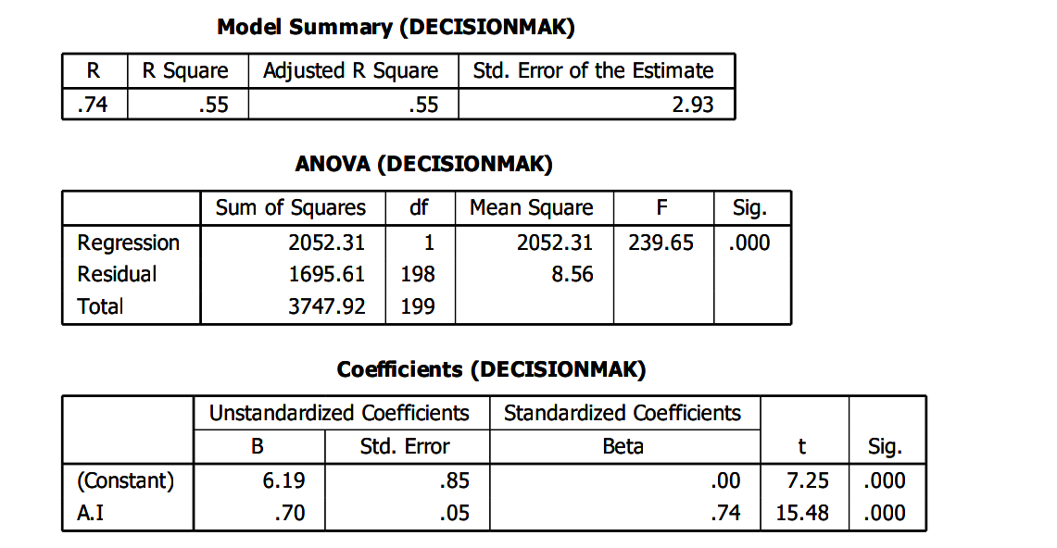
This is the multiple correlation coefficient, showing the strength of the relationship between the independent variable(s) and the dependent variable. An R of .74 indicates a strong positive relationship between Artificial Intelligence (A.I) and fraud detection efficiency. R Square = .55 This means that 55% of the variation in decision-making is explained by A.I. This is a substantial amount of variance explained, suggesting that A.I. is a strong predictor of fraud detection efficiency. Adjusted R Square = .55 Since there is only one independent variable (A.I.), the Adjusted R² is the same as R². It confirms the stability of the model without inflation due to multiple predictors. Std. Error of the Estimate = 2.93 This indicates the average distance that the observed values fall from the regression line. Smaller values indicate more accurate predictions. F = 239.65, p = .000 The F-statistic tests the overall significance of the model. Since the p-value = .000 (< 0.05), the regression model is statistically significant. This means that A.I. contributes significantly to fraud detection efficiency. The regression analysis shows that A.I. has a strong, positive, and statistically significant effect on fraud detection efficiency. With an R² of .55, more than half of the variance in fraud detection efficiency can be explained by A.I. This highlights the importance of A.I. in enhancing fraud detection efficiency. The F-test confirms that the regression model is statistically valid, while the coefficients indicate that as organizations increase their adoption or reliance on A.I., fraud detection efficiency improves significantly. The strong Beta value (0.74) reinforces that A.I. is a powerful determinant of fraud detection efficiency.

  - Discussions of Findings
All the null hypotheses tested were rejected as their corresponding p-values were below the significance level of 0.05. This study clarifies the ambiguity surrounding compensation in relation to employee performance. The results obtained are consistent with the majority of existing research, reinforcing the significance of A.I on the dependent variables.

Hypothesis One: The integration of artificial intelligence significantly affects employment levels or job roles within the insurance industry.
The study explores whether the integration of artificial intelligence significantly affects employment levels within the insurance industry or not. The responses from the questionnaire support those findings with majority of participants recognizing that A.I significantly affects employment levels within the insurance industry. The strong statistical evidence from this study supports the hypothesis that there is significant relationship between A.I and employment levels. The result of the findings indicated significant correlation between the variables. The findings indicated the adoption of A.I in insurance industry is creating new job opportunities. It is therefore suggested that there is need for management to invest in continuous training and launch certification programs, workshops and online courses that are tailored to A.I related competencies. These findings are consistent with the study by Dubyna et al. (2025). They highlighted how AI enables insurers to provide 24/7 support, offer policy recommendations, and personalize offerings using behavioral data. Similarly, BGL Group’s use of chatbot AI significantly enhanced customer satisfaction by addressing inquiries efficiently and guiding policy purchases. It is recommended that both the Government and industry bodies should collaborate to develop A.I ethics and employment guidelines. It is also recommended that public-private initiatives should be funded for workforce transformation

Hypothesis Two: Artificial intelligence has no significant effect on underwriting accuracy, claims processing speed, or fraud detection efficiency in the insurance industry.
The analysis revealed that there is a positive relationship between cultural context and the demand for life insurance as confirmed by high statistical significance. The findings indicated that A.I is seen to enhance risk prediction and customer behaviour analysis. It is suggested that there is need for management to invest in A.I tools such as predictive analytics, customer behaviour modelling since respondents believe A.I supports better predictions and decision making. Organizations should also integrate machine learning for fraud detection, claims analysis, and risk profiling in enhancing risk management. These findings are consistent with the existing empirical study by Dubyna et al. (2025) stating that AI-based models improve underwriting efficiency by analyzing vast datasets, including behavioral, demographic, and transactional data, to predict risk profiles. Cosentino (2024) observed that machine learning and NLP algorithms can process repetitive tasks, such as document verification and claim categorization, minimizing human errors. The study's findings advised that A.I use should be encouraged in insurance industry to ensure consistency and accountability.

